AI DRIVEN
NETWORK SECURITY SYSTEM

AJAY KUSHWAHA MOHIT SINGH YADAV

ANKIT RAJ SHASHANK KUMAR SRIVASTAVA ARYAN GUPTA
satan4002849@gmail.com shashanksrivastav9800@gmail.com aryangupta0626@gmail.com

Abstract -- Network security remains one of the most pressing challenges in today's digital landscape. This paper delves into how AI can enhance network security through various applications such as monitoring malicious code, detecting smartphone intrusions, ensuring HTTP security, and supervising voice activity on public networks. Techniques like using Artificial Neural Networks (ANNs) to identify and mitigate DDoS attacks across TCP, UDP, and ICMP protocols are particularly effective.
We also discuss threats posed by malicious uses of AI and propose strategies to address them. For instance, when protecting HTTP services, it's crucial to consider the broader attack surface, not just the protocol itself. Additionally, we highlight promising directions for future research, such as combining cloud computing with deep learning to create more robust security solutions.

Keywords: Network Security, Threat Detection, Real-time Monitoring, Deep Learning, Machine Learning.

- INTRODUCTION

In today's digital era, where interconnected systems form the backbone of modern communication and business operations, network security has emerged as a crucial concern for organizations. The increasing complexity and frequency of cyberattacks—ranging from zero-day attacks and ransomware to Distributed Denial of Service (DDoS) attacks—demand innovative and adaptive solutions. This challenge is further compounded by the rapid advancement of technology, which has expanded the scope of cyber risks to include data destruction, privacy breaches, and the exploitation of emerging technologies like smart cities and networks [1].

The AI-Driven Network Security System addresses these challenges by leveraging artificial intelligence and machine learning to enhance the detection, prevention, and mitigation of cyber threats. The system adopts a proactive approach to network protection by dynamically responding to potential threats, identifying anomalies, and monitoring network traffic in real time. Unlike traditional methods, the AI system learns from past data to continuously improve its capabilities, ensuring the identification and mitigation of both known and unknown threats. This adaptive and scalable solution not only strengthens security infrastructure but also reduces false alarms, minimizes response times, and alleviates the workload on IT security teams [2].

The project underscores the potential of artificial intelligence in revolutionizing network security practices. With its ability to automate detection and response processes, it ensures continuous, real-time defence against sophisticated cyberattacks while reducing the reliance on human intervention. At the same time, the system's design addresses challenges related to data security, communication security, and privacy protection, paving the way for secure implementation in scenarios such as smart cities and networks. This project ultimately provides businesses and organizations with an intelligent, reliable, and efficient security solution that evolves alongside emerging cyber threats, ensuring robust and resilient network defences [3].

- BACKGROUND AND EVOLUTION OF NETWORK SECURITY

Network security has always been at the heart of protecting the digital systems that underpin modern communication and business operations. Over the years, as networks expanded and became more complex, so did the threats they faced. This evolution has been shaped by both the changing nature of cyberattacks and the technological advances made to counter them.

Traditional Approaches

- Rule-Based Systems and Firewalls
Early network security relied on rule-based systems to enforce pre-defined protocols for data traffic. Firewalls were among the first lines of defence, designed to block unauthorized access based on these static rules. While effective against known threats, these systems often lacked flexibility, struggling to address more complex or previously unseen attacks.

- Intrusion Detection and Prevention Systems (IDPS)
As cyber threats became more advanced, Intrusion Detection and Prevention Systems (IDPS) emerged. These systems monitored network traffic, identifying suspicious activities and alerting administrators to potential breaches. While they added an additional layer of protection, they were prone to false positives and required regular manual updates to remain effective[4].

- Limitations of Static Models Against Dynamic Threats
A key limitation of traditional approaches was their dependence on static models, making them only as effective as their predefined rules or signatures. This left them vulnerable to evolving and dynamic threats like zero-day exploits and advanced persistent threats (APTs).

Emergence of AI in Security

- Introduction of Machine Learning and Deep Learning
The integration of machine learning (ML) and deep learning (DL) marked a significant turning point in network security. Unlike traditional methods, ML algorithms could analyse large datasets to identify patterns and anomalies that might indicate a threat. Deep learning further enhanced this capability, enabling systems to detect even the most complex attack vectors[5][6].

- Transition from Reactive to Proactive Threat Management
AI brought a shift from reactive to proactive security measures. Traditional systems often responded to threats after they occurred, whereas AI-driven systems are designed to predict and prevent potential attacks. By analysing real-time data and historical trends, these systems can identify vulnerabilities and mitigate risks before they escalate.

- Adoption of Automation for Real-Time Threat Response
One of the most groundbreaking applications of AI in network security is its capability to automate threat responses. Unlike traditional methods that rely on manual intervention, AI-driven systems can react instantly, neutralizing threats as they arise. This not only enhances response efficiency but also minimizes the risk of human error, ensuring a more resilient security framework.

- METHODS AND APPLICATIONS

The integration of advanced technologies like machine learning (ML) and artificial intelligence (AI) has revolutionized the way network security operates. These methods have enabled smarter, faster, and more efficient ways to identify and mitigate threats, creating a more robust defence system.

Machine Learning in Network Security
Machine learning has become one of the most critical tools in network security, leveraging its ability to analyse large volumes of data and uncover hidden patterns[7].

- Supervised, Unsupervised, and Reinforcement Learning Models
Different types of ML models have found their place in network security. Supervised learning relies on labelled data to classify threats, while unsupervised learning identifies anomalies in unlabelled datasets, making it particularly useful for unknown or zero-day threats. Reinforcement learning takes a more dynamic approach, using feedback loops to optimize responses to evolving threats over time[8].

- Practical Applications
ML is widely used for tasks such as anomaly detection, where it identifies unusual behaviour in network traffic. It is also effective in pattern recognition, which helps pinpoint malicious activities, and in predictive analytics, allowing systems to anticipate and prevent potential attacks.

Deep Learning for Advanced Threat Detection
Deep learning takes threat detection to a whole new level by employing neural networks capable of processing vast and complex datasets.

- Detecting Complex Attack Patterns
Neural networks excel at identifying sophisticated attack vectors that might bypass traditional security measures. Their ability to process non-linear relationships makes them particularly effective against multi-stage attacks.

- Natural Language Processing (NLP) in Phishing Detection
NLP has become a game-changer in identifying phishing attempts. By analysing the language and structure of emails or messages, deep learning models can flag suspicious communications with high accuracy, reducing the chances of users falling victim to phishing scams[9][10].

Automation and Real-Time Response
AI has also brought automation to the forefront of network security, making responses faster and more efficient.

- Automated Security Orchestration
AI-driven systems can automate the entire security workflow, from detecting threats to implementing countermeasures. This not only minimizes human involvement but also ensures consistent and timely action.

- Cost and Time Efficiency
By significantly reducing response times, automation helps mitigate potential damages quickly while lowering operational costs associated with manual monitoring and intervention.

Hybrid Systems
The combination of traditional security measures and AI-driven technologies has resulted in hybrid systems that offer the best of both worlds.

- Integrated Approach
Traditional rule-based systems provide a strong foundation, while AI enhances their capabilities by adding adaptability and scalability. For instance, while firewalls set static rules, AI can dynamically adjust those rules based on real-time data.

- Advantages of Hybrid Systems
Combining these approaches ensures a more comprehensive security strategy. Rule-based systems handle known threats reliably, while AI tackles emerging and previously unseen risks. This synergy enhances overall network resilience and effectiveness.

- BACKGROUND

The expansion of computer networks has reshaped the way societies operate, but it has also led to a surge in both the frequency and sophistication of cyberattacks. These attacks, which target computer systems, networks, and sensitive data, are often meticulously planned and executed in coordinated stages to maximize their impact. As cyber threats continue to evolve, traditional security measures struggle to keep pace, highlighting the need for more advanced and adaptive defence mechanisms. [11].
In an era where digital connectivity underpins nearly every aspect of modern life, securing network infrastructures has become a top priority for organizations. Traditional security measures, such as firewalls and signature-based detection systems, have long served as the first line of defense. However, these static solutions struggle to keep pace with rapidly evolving cyber threats, leaving networks vulnerable to sophisticated attacks like zero-day exploits and advanced persistent threats (APTs).

The increasing complexity and scale of cyberattacks have highlighted the need for more adaptive and intelligent security mechanisms. Attackers continuously refine their techniques, making it difficult for rule-based systems to detect novel threats. Additionally, manual threat response methods are often slow and prone to human error, further exacerbating security risks. These challenges have prompted a shift toward AI-driven solutions, which offer a dynamic, data-driven approach to threat detection and response.

By leveraging machine learning and deep learning algorithms, AI-powered security systems can analyse vast amounts of network data in real time, identifying anomalies and patterns indicative of potential attacks. Unlike conventional security frameworks, these systems continuously learn and improve, enabling them to detect emerging threats with greater accuracy. This transformation in network security represents a fundamental shift from reactive defence strategies to proactive threat mitigation, significantly enhancing the resilience of modern digital infrastructures.

Intending to cause damage, unauthorized access, or service interruptions that cause
severe data loss or financial damage and often lead to long-lasting consequences, these are the insider threats that represent a significant and growing segment of these attacks, usually committed by disgruntled or rogue employees who exploit their authorized access to steal data or cause harm. These threats can also emerge from intrusive applications that users accidentally install on their devices, allowing these apps to access and misuse sensitive information. Advanced behavioural anomaly detection and auto-resiliency mechanisms are being developed to combat these threats by proactively identifying and mitigating malicious actions at both the employee and application levels[12].

There is a broad spectrum of cyber-attacks that represent a variety of threats in the digital world. Insights into several critical types of these attacks are provided, as highlighted in the literature and summarized in Table 1. This information emphasizes the complexity and wide range of cyber threats, illustrating the many attacks organizations and individuals may encounter in today’s interconnected environment. Botnets, another critical cyber threat, are networks of infected computers controlled by an attacker to perform coordinated malicious activities, such as DDoS attacks, data theft, and spamming. These networks can be vast, comprising thousands or even millions of
compromised devices, which makes them incredibly difficult to dismantle. Botnet operators use sophisticated methods to infect devices and maintain control, continuously evolving their techniques to avoid detection[13].

- ARITIFICIAL INTELLGENCE

The growing complexity of cyber threats has made attack detection a critical focus within the cybersecurity community. To counter these threats, organizations have adopted comprehensive monitoring strategies that track network activity, system behaviour, and user patterns to identify and neutralize unauthorized access attempts. Artificial Intelligence (AI), along with its subsets like Machine Learning (ML) and Deep Learning (DL), has emerged as a powerful tool in this domain. AI’s ability to process vast amounts of data in real time, recognize patterns, and continuously learn from new threats makes it highly effective in detecting malware, phishing attempts, network intrusions, and other cyberattacks[14].

AI-driven cybersecurity solutions address one of the key limitations of traditional security methods—their inability to adapt to new, unknown threats. Conventional rule-based systems rely on predefined attack signatures, making them ineffective against zero-day exploits and rapidly evolving threats. In contrast, AI models leverage predictive analytics to anticipate vulnerabilities before they are exploited, allowing for a more proactive security approach. Additionally, AI enhances decision-making by reducing false positives, a common issue in traditional intrusion detection systems, ensuring more accurate threat identification and response [15].A variety of AI techniques are being applied to strengthen cybersecurity defenses. ML algorithms enable systems to identify and classify threats without explicit programming, continuously improving their detection accuracy. DL, inspired by neural networks, processes large datasets to recognize complex attack patterns, mimicking human cognitive functions for deeper threat analysis. Beyond these methods, integrating metaheuristic algorithms with AI models has shown significant promise in optimizing threat detection. These algorithms enhance the learning process by expanding the search space explored during model training, improving detection accuracy and adaptability to evolving cyber threats [16].

The integration of AI into cybersecurity is not just about improving detection—it also enhances the efficiency of response mechanisms. Traditional security systems often require human intervention to analyze threats and determine the appropriate countermeasures. This delay can be costly, as cyberattacks operate at high speeds, potentially causing irreversible damage within seconds. AI-powered systems, however, can automate threat response by isolating compromised network segments, blocking malicious IP addresses, and deploying countermeasures in real time. This level of automation significantly reduces the time between threat detection and mitigation, strengthening an organization’s overall security posture.

Another major advantage of AI-driven cybersecurity is its ability to handle the increasing volume of cyber threats without compromising accuracy. With the rise of the Internet of Things (IoT) and cloud computing, networks are more interconnected than ever, creating vast

amounts of data that need continuous monitoring. AI excels in processing this data efficiently, identifying anomalies that may indicate a security breach. By leveraging unsupervised learning techniques, AI can recognize unusual patterns without relying on predefined attack signatures, allowing it to detect even the most sophisticated and previously unknown threats.

Furthermore, AI enhances threat intelligence by correlating data from multiple sources to provide a more comprehensive understanding of cyber risks. By analyzing past attack patterns, AI can predict future threats and recommend preventive measures, helping organizations stay ahead of cybercriminals. This predictive capability is especially valuable in securing critical infrastructures such as financial systems, healthcare networks, and government databases, where data breaches can have far-reaching consequences.

The future of cybersecurity lies in the continued refinement and integration of AI technologies. As adversaries develop more advanced attack techniques, AI-driven security systems must evolve in tandem, leveraging innovations like federated learning, adversarial AI defense strategies, and hybrid AI-human collaboration models. By combining AI’s computational power with human expertise, organizations can create more resilient security frameworks capable of defending against even the most sophisticated cyber threats.

Advantages of Metaheuristic Algorithms in Cyber Attack Detection:

Optimization: They help find the most effective solutions for detecting cyber threats, even in highly complex and dynamic environments.

Automation: By fine-tuning detection parameters autonomously, they minimize human intervention and increase reliability.

Speed: Their ability to quickly converge on optimal solutions makes them highly effective in time-sensitive cybersecurity operations.

As cyber threats continue to evolve, AI-driven security solutions—augmented by advanced optimization techniques—offer a scalable, intelligent, and highly responsive approach to safeguarding digital infrastructures. This integration of AI, ML, DL, and metaheuristic algorithms is redefining cybersecurity, transforming it from a reactive defense mechanism into a proactive and predictive security framework

- MACHINE LEARNING

Machine Learning (ML) is a field that enables computers to analyze data, identify patterns, and make informed decisions without being explicitly programmed for specific tasks. By leveraging historical data, ML models can predict future outcomes, continuously improving their accuracy over time. As cyber threats become more dynamic and sophisticated, ML plays a crucial role in automating threat detection, enhancing security protocols, and responding to attacks in real time.

ML algorithms can be broadly classified based on their learning approach and complexity. Supervised learning involves training models on labeled data, enabling them to classify threats or recognize malicious activity based on known attack patterns. Unsupervised learning, on the other hand, is useful for anomaly detection, as it identifies deviations from normal network behavior without requiring predefined labels. Reinforcement learning further enhances cybersecurity by enabling AI-driven systems to learn from interactions, adapting their responses to evolving threats over time.

The architecture of ML models varies depending on the complexity of the security challenge they aim to address. Traditional decision trees and support vector machines (SVMs) offer interpretable solutions for structured cybersecurity tasks, while deep learning models, such as convolutional neural networks (CNNs) and recurrent neural networks (RNNs), are better suited for analyzing large-scale network traffic and detecting advanced cyber threats. Additionally, hybrid models that combine multiple learning techniques are gaining popularity in cybersecurity, as they balance accuracy, efficiency, and adaptability.

By integrating diverse ML algorithms and architectures, AI-driven cybersecurity systems can proactively detect, mitigate, and prevent cyber threats with greater accuracy and efficiency. This continuous evolution of ML-based security frameworks is transforming cybersecurity from a reactive defense mechanism into a predictive and adaptive security strategy. [17].

ML algorithms are divided into supervised, unsupervised, semi-supervised, and RL, as shown in Fig. 2 [18].
A variety of supervised and unsupervised learning techniques have been applied to
develop advanced and effective models capable of identifying and categorizing attacks.

- DEEP LEARNING

Deep Learning (DL) is a specialized branch of Machine Learning (ML) that focuses on hierarchical representation learning, where data is processed through multiple layers of transformations. This multilayered approach allows DL models to achieve superior accuracy in detection and prediction tasks, making them particularly valuable in cybersecurity. DL-driven security mechanisms are increasingly deployed to automate cyber threat detection, continuously refining their capabilities to counter evolving attack techniques[19].

The foundational structure of DL models consists of an input layer, multiple hidden layers, and an output layer. Unlike traditional neural networks with a single hidden layer, Deep Neural Networks (DNNs) utilize multiple hidden layers, allowing for complex pattern recognition and feature extraction. These deep architectures, based on Artificial Neural Networks (ANNs), facilitate the flow of information between interconnected neurons, each applying activation functions such as ReLU (Rectified Linear Unit) or tanh to enhance non-linearity and improve learning efficiency. As data propagates through these layers, the model refines its understanding of network anomalies, cyberattack patterns, and intrusion behaviours [20].

DL models have a wide range of applications in cybersecurity, including intrusion detection systems (IDS), false data injection detection, malware classification, and network anomaly detection. Advanced architectures like Convolutional Neural Networks (CNNs) and Recurrent Neural Networks (RNNs) have been particularly effective in processing structured and sequential cybersecurity data, such as network traffic logs and system event sequences. Additionally, autoencoders and generative adversarial networks (GANs) are being explored for anomaly detection, helping organizations identify previously unknown attack patterns.

The growing adoption of DL in cybersecurity is reshaping traditional defense strategies, enabling real-time threat mitigation and proactive security measures. As these systems continue to evolve, their ability to adapt to emerging cyber threats will further strengthen the resilience of modern digital infrastructures.

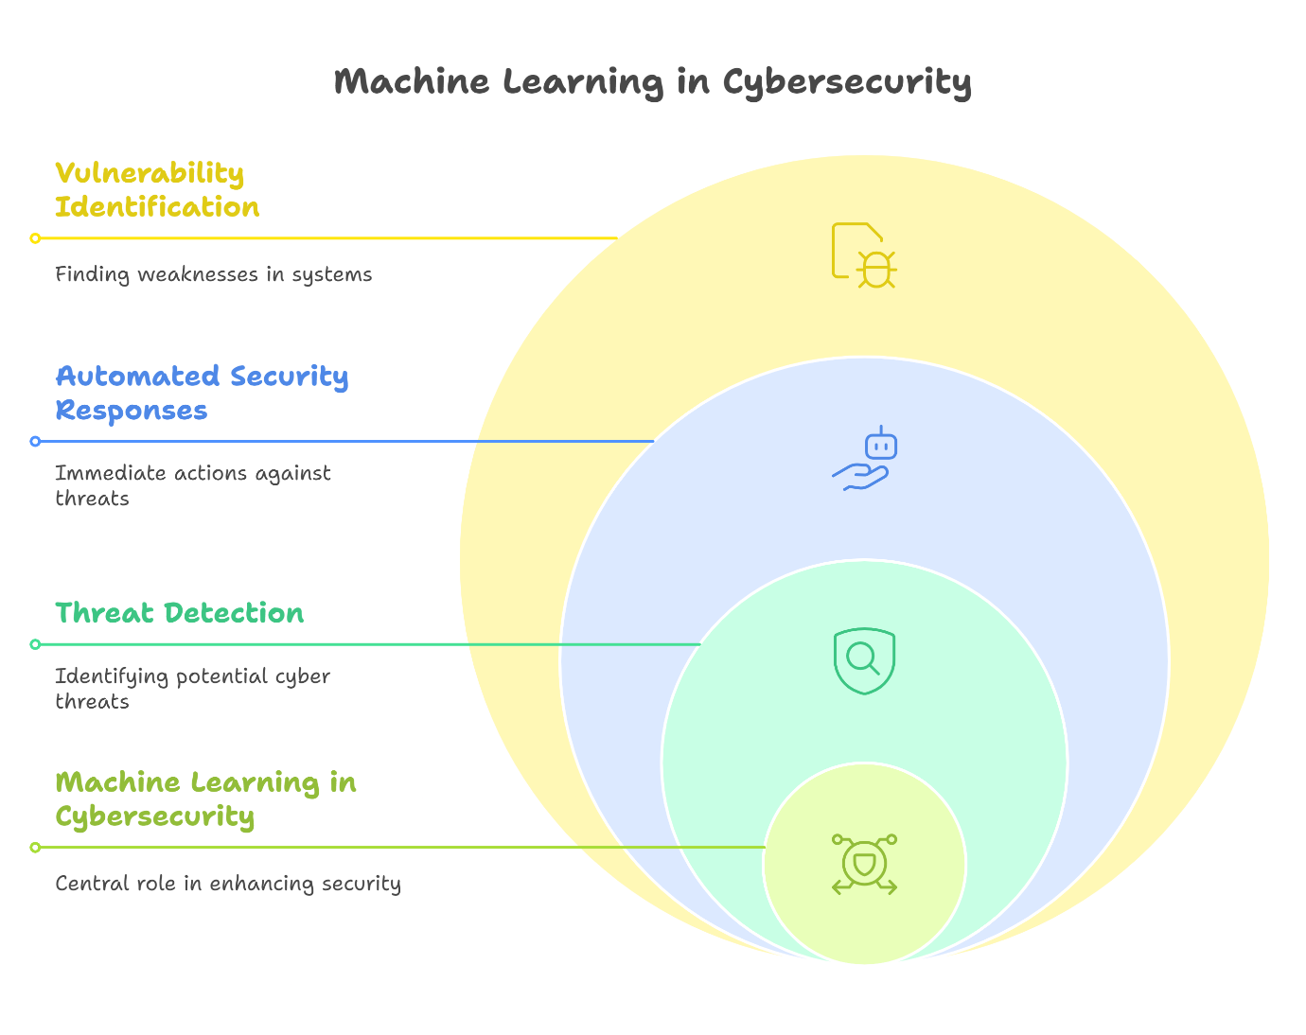

- METAHUERISTIC

Metaheuristic algorithms are powerful optimization techniques designed to efficiently identify optimal or near-optimal solutions for complex problems. Unlike traditional gradient-based methods, these algorithms operate without requiring derivative calculations, making them highly adaptable across various problem domains.
Their approach begins with one or multiple randomly generated solutions, gradually refining them through iterative processes. By maintaining a balance between exploration—searching diverse areas of the solution space—and exploitation—focusing on promising regions for refinement, metaheuristics effectively navigate complex landscapes while avoiding local optima. This balance allows them to discover high-quality solutions in scenarios where conventional methods may struggle.
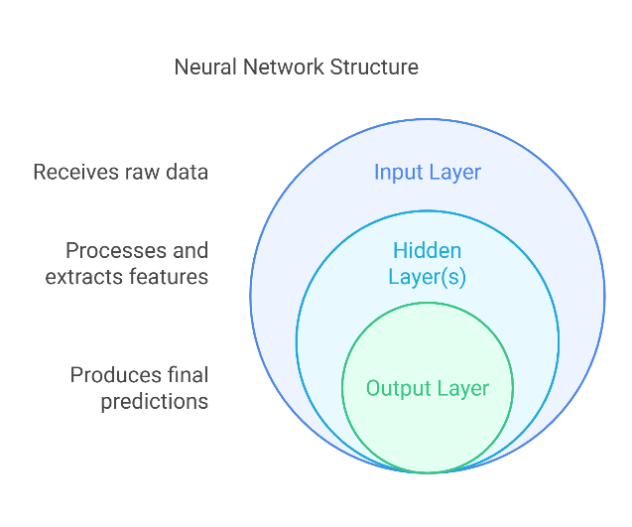
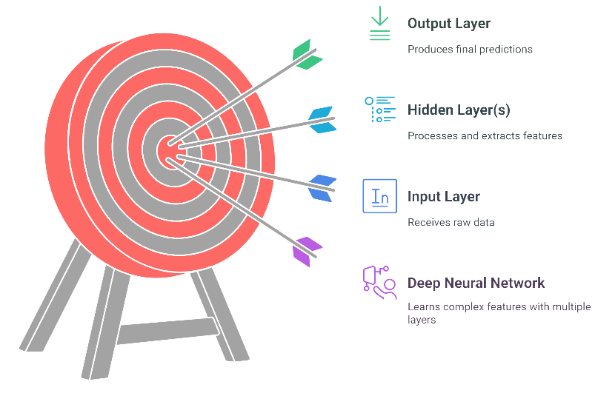

FIG 3. NEURAL NETWORKS VS DEEP NEURAL NETWORKS

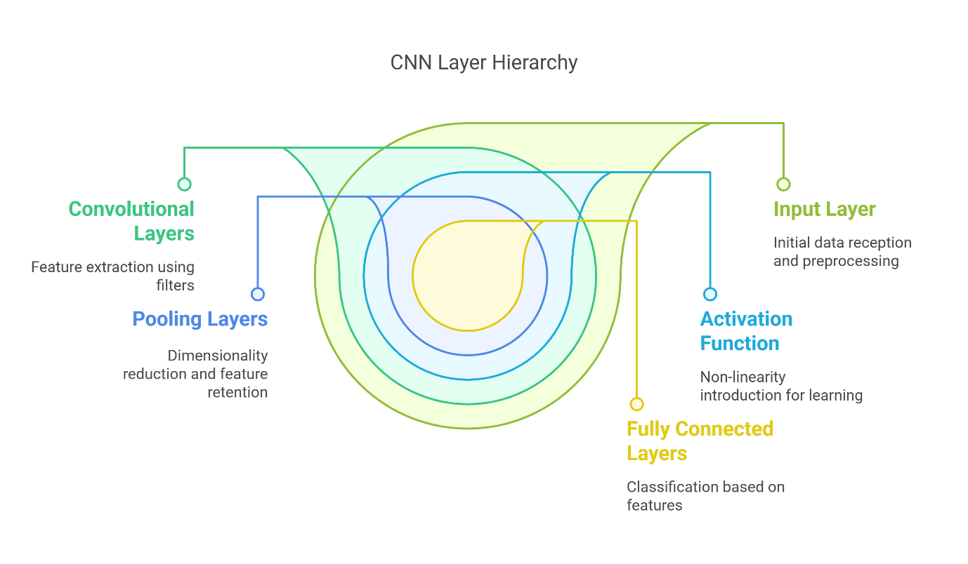
FIG 4. CNN STRUCTURE

Metaheuristic algorithms represent advanced global optimization techniques influenced by simulations and nature-inspired processes. These strategies draw inspiration from the collective behaviors observed in species like fish, birds, ants, and other social organisms. The way these

creatures coordinate and solve complex challenges has laid the foundation for optimization algorithms that efficiently navigate large search spaces. Over the years, these algorithms have proven highly effective in solving real-world optimization problems by leveraging the principles of self-organization and adaptive learning.
Metaheuristic techniques are broadly categorized into four main groups: evolution-based, swarm intelligence-based, physics-based, and human-related algorithms. Each category employs unique problem-solving mechanisms, but all share the core objective of striking a balance between exploration—searching diverse areas for potential solutions—and exploitation—refining promising candidates to achieve optimal performance.

In summarizing the background of this study, we have examined the evolving landscape of cybersecurity, emphasizing the rise of cyber threats and the pressing need for robust detection mechanisms. The integration of AI, ML, and DL with metaheuristic algorithms has been highlighted as a highly effective approach for enhancing threat detection and response. This fusion of technologies strengthens cybersecurity frameworks by improving real-time adaptability and predictive accuracy, forming a comprehensive defense against modern cyber risks.

- LITERATURE REVIEW

Recent advancements in computing, particularly in AI, have profoundly transformed various aspects of daily life and professional environments. AI-driven systems can now perform tasks that traditionally required human intelligence, excelling in real-time analysis and decision-making. With the ability to process vast amounts of data, AI has become indispensable in tackling complex problems across scientific and technological domains. This capability is especially crucial in cybersecurity, where the sheer volume of network activity and the increasing sophistication of threats make manual monitoring and response impractical. AI’s integration in cybersecurity has the potential to significantly reduce the costs and time involved in developing threat recognition models, despite the high expenses associated with employing specialized experts.

AI plays a multifaceted role in cybersecurity, enabling efficient and accurate analysis of large datasets while leveraging historical attack patterns to predict and mitigate emerging threats. Its adaptability allows it to detect subtle variations in attack methodologies, manage extensive data streams, and facilitate continuous learning for improved security responses. These attributes make AI a valuable asset in cyber defense, strengthening detection mechanisms against malware, network intrusions, insider threats, botnets, and phishing attacks.

However, implementing AI in cybersecurity comes with its own set of challenges. AI systems require extensive datasets for effective training, which demands significant computational resources. Additionally, false positives can undermine trust in AI-driven security solutions, while slow response times may weaken overall effectiveness. AI-based security frameworks themselves are also susceptible to adversarial attacks, making them both a tool for defense and a potential target. Despite these challenges, ongoing research is focused on enhancing AI’s resilience and adaptability in cybersecurity.

This survey presents a comprehensive exploration of AI-driven security strategies, covering a wide range of machine learning (ML), deep learning (DL), and metaheuristic techniques. Unlike many studies that focus on only one or two of these approaches, our research thoroughly examines their combined applications in cybersecurity. We analyze over sixty recent studies, comparing various AI methodologies and their effectiveness in detecting and mitigating cyber threats. Additionally, our work provides an extensive list of publicly available datasets used for AI model validation, ensuring that findings are grounded in real-world scenarios.

Beyond a technical analysis, this paper emphasizes the practical implementation of AI in different environments, including IoT, cloud computing, and traditional enterprise networks. It highlights AI’s advantages in automation and real-time threat mitigation while also addressing key areas for future research, such as improving model transparency, explainability, and early AI integration into security workflows for proactive defense.

Comparisons with prior research, such as [24] and [25], highlight gaps in existing surveys. For instance, while [24] explores AI applications in cybersecurity—covering malware detection, intrusion detection, and vulnerability assessment—it lacks insights into AI’s integration with blockchain for data integrity and does not sufficiently discuss real-world case studies or legal, ethical, and privacy concerns. Additionally, while [25] categorizes AI vulnerabilities into manipulation and extraction attacks, it is limited to specific domains and could benefit from broader cross-disciplinary perspectives. Our study addresses these gaps by providing a well-rounded analysis of AI, ML, and DL techniques alongside their challenges and potential improvements.

By taking a comprehensive approach, this paper contributes to the growing field of AI-powered cybersecurity, offering actionable recommendations for future research and practical implementation strategies to enhance security frameworks across industries.

- CONCLUSION

The development of the AI-Driven Network Security System marks a significant advancement in the fight against ever-evolving cyber threats. This research has demonstrated the potential of integrating artificial intelligence with traditional security measures to create a more adaptive, efficient, and proactive defence mechanism. By leveraging machine learning, deep learning, and automation, the system not only enhances threat detection and response capabilities but also reduces human dependency, operational costs, and response times.

Our study presents a comprehensive review of AI-driven methodologies in cyber-attack detection, emphasizing the crucial role of machine learning, deep learning, and metaheuristic algorithms in strengthening cybersecurity frameworks. These advanced technologies not only improve detection accuracy but also facilitate real-time threat mitigation, making them essential tools in modern cyber defense.

Despite their effectiveness, these AI-based approaches come with notable challenges. High computational costs, the necessity for extensive and reliable datasets, and the susceptibility to adversarial attacks highlight the need for ongoing research and innovation. As cyber threats continue to evolve, refining AI-driven security mechanisms will be critical in ensuring robust and adaptive protection against emerging risks.

Key findings from this research emphasize that while AI technologies have the potential to revolutionize network security, their success relies on addressing these limitations. Future work should focus on optimizing computational efficiency, improving data acquisition processes, and developing robust systems that can adapt to increasingly sophisticated cyber threats
.
In conclusion, integrating AI into network security marks a significant advancement, providing scalable and intelligent solutions to counter evolving cyber threats. By merging technological innovation with strategic deployment, this project establishes a strong foundation for a more resilient and secure digital landscape.

- FUTURE SCOPE

- Enhanced Threat Detection and Prevention
While current AI models are effective, there is still room for improvement in identifying emerging, previously unknown threats. Future AI systems could utilize advanced techniques, such as federated learning, where models are trained on decentralized data across different networks, improving detection without compromising privacy.

Additionally, AI could become even more adept at detecting multi-stage or highly complex attack vectors, such as advanced persistent threats (APTs), by incorporating more sophisticated deep learning techniques and enhancing anomaly detection.

- Integration with Next-Generation Security Frameworks
As organizations adopt more complex architectures such as cloud environments, IoT devices, and 5G networks, AI-driven systems will need to adapt and integrate seamlessly with these next-generation security frameworks. Future AI systems could provide cross-platform protection, combining the strengths of traditional security tools with AI’s real-time adaptive capabilities to offer holistic and unified defence mechanisms.

- Improved Automation and Response Capabilities
While AI can already respond to threats in real time, future advancements could see even more sophisticated automated defence strategies. AI-powered security systems could autonomously decide on the most effective countermeasures based on an attack's nature, such as adjusting firewall rules, rerouting traffic, or isolating affected systems without human intervention.

This level of automation could significantly reduce the workload on IT teams, enabling them to focus on more complex issues while AI handles routine threat mitigation.

- Reducing Computational Overhead
As AI algorithms become more powerful, they also demand higher computational resources, which can be a barrier for some organizations. Future research could focus on optimizing these algorithms to run more efficiently, reducing the hardware costs associated with implementing AI-driven security systems. Innovations in edge computing, where processing is done closer to the data source, could help reduce latency and improve real-time threat detection.

- Ethical and Privacy Considerations
As AI systems continue to play a larger role in network security, addressing their ethical implications will be crucial. Future advancements must prioritize data privacy and user rights, ensuring that security measures do not come at the cost of personal confidentiality. This involves developing AI models capable of detecting malicious activity while maintaining anonymity and safeguarding sensitive information.

Furthermore, ensuring transparency and accountability in AI decisions, particularly when these decisions impact security policies or user access, will be a key area of development.

- Collaboration and Intelligence Sharing
AI could also play a major role in fostering collaboration among organizations by enabling the sharing of threat intelligence in real time. AI systems could be used to aggregate and analyse threat data from various sources, providing organizations with insights into emerging threats and allowing them to adjust their security postures accordingly. Collaborative AI platforms could even allow for the creation of shared, community-driven defence strategies against global cyber threats.

- Advancements in Metaheuristic Algorithms
Future research into metaheuristic algorithms, which are designed to find optimal solutions to complex problems, could further improve the efficiency and accuracy of AI models in network security. These algorithms can be used to enhance the adaptive capabilities of AI systems, allowing them to learn more effectively from dynamic environments and continuously evolve to combat new threats.

- REFERENCES

[1] Cybersecurity Ventures. (2020). "Cybercrime To Cost the World $10.5 Trillion Annually By 2025." Retrieved from https://cybersecurityventures.com/cybercrimedamages-6-trillion-by-2021/

[2] Capgemini Research Institute. (2019). "Reinventing Cybersecurity with Artificial Intelligence." Retrieved from
https://www.capgemini.com/research/reinventin g-cybersecurity-with-artificial-intelligence/
\
[3] Stallings, W., & Brown, L. (2018). Computer Security: Principles and Practice. Pearson Education.

[4] Karen Scarfone & Peter Mell, “Guide to Intrusion Detection and Prevention Systems (IDPS)”, NIST Special Publication on Computer security, February 2007.

[5] Nourhan HALAWI GHOSON, Vincent MEYREUISIS, Khaled BENFRIHA.

[6] 11. Langley, Pat (2011). "The changing science of machine
learning". Machine Learning. 82 (3): 275–279.Doi:10.1007/s10994-011-5242-y

[7] Alpaydin, Ethem (2010). Introduction to Machine Learning. MIT Press. p. 9
ISBN 978-0-262-01243-0

[8] [Alpaydin, 2020] Alpaydin, E. (2020). Introduction to Machine Learning
(fourth edition). MIT Press

[9] Reinheimer, B., et al.: An investigation of phishing awareness and education over time: when and how to best remind users. In: Sixteenth Symposium on Usable Privacy and Security (SOUPS 2020), pp. 259–284. USENIX Association, August 2020. ISBN 978-1-939133-16-8 https://www.usenix.org/conference/soups2020/presentation/reinheimer

[10] The Real Reason for Successful Phishing Attacks. https://blog.usecure.io/the-real-reason-why-phishing-attacks-are-so-successful

[11] Uma M, Padmavathi G. A survey on various cyber-attacks and their classification. Int J Newt Secure. 2013;15(5):390–6. https://doi.org/10.6633/IJNS.201309

[12] Rauf U, Mohsen F, Wei Z. A taxonomic classification of insider threats: existing techniques, future directions and
recommendations. J Cyber Secure Mobil.2023;12(2):221–52. https://doi.org/10.13052/jcsm2245-1439.1225.
[13] Thanh SN, Stege M, El-Habr PI, Bang J, Dragoni N. Survey on botnets: incentives, evolution, detection and current trends. Future Internet. 2021. https://doi.org/10.3390/f13080198.

[14] Parizad A, Hatziadoniu CJ. Cyber-attack detection using principal component analysis and noisy clustering algorithms: a collaborative machine learning-based framework. IEEE Trans Smart Grid. 2022;13(6):4848–61.
https://doi. org/10.1109/TSG.2022.3176311.

[15] Hua Li J. Cyber security meets artifcial intelligence: a survey. Front Inf Technol Electron Eng. 2018;19(12):1462–74.
https://doi.org/10.1631/FITEE.180057.

[16] Welukar JN, Bajoria GP. Artifcial intelligence in cyber security—a review. Int J Sci Res Sci Technol. 2021. https://doi. org/10.32628/IJSRST218675.

[17] Kuntla GS, Tian X, Li Z. Security and privacy in machine learning: a survey. Issues Inf Syst. 2021;22(3):224–40. https://doi.org/10.48009/3_iis_2021_242-258.

[18] Thomas T, Vijayaraghavan AP, Emmanuel S. Machine learning approaches in cyber security analytics. 2019. https:// doi.org/10.1007/978-981-15-1706-8.

[19] Sarker IH, Kayes ASM, Badsha S, Alqahtani H, Watters P, Ng A. Cybersecurity data science: an overview from machine learning perspective. J Big Data. 2020. https://doi.org/10.1186/s40537-020-00318-5.

[20] Barik K, Misra S, Konar K, Fernandez-Sanz L, Koyuncu M. Cybersecurity deep: approaches, attacks dataset, and comparative study. Appl Artif Intell. 2022. https://doi.org/10.1080/08839514.2022.2055399.

[21] Hasan M, Islam MM, Zarif MII, Hashem MMA. Attack and anomaly detection in IoT sensors in IoT sites using machine learning approaches. Internet Things. 2019;7:100059. https://doi.org/10.1016/j.iot.2019.100059.

[22] Dokur NB. Artifcial Intelligence (AI) applications in cyber security. https://www.researchgate.net/publication/ 367253331

[23] Role of AI in cyber security through Anomaly detection and Predictive analysis. J Inf Educ Res. 2023;3:2. https:// doi.org/10.52783/jier.v3i2.314.

[24] Ozkan-Okay M, et al. A comprehensive survey: evaluating the efciency of artifcial intelligence and machine learning techniques on cyber security solutions. IEEE Access. 2024;12:12229–56. https://doi.org/10.1109/ACCESS. 2024.3355547.

[25] Sangwan RS, Badr Y, Srinivasan SM. Cybersecurity for AI systems: a survey. J Cybersecur Privacy. 2023;3(2):166–90. https://doi.org/10.3390/jcp3020010.

